Ledyard Youth League | 2/7/2023  6:02 PM  Ledyard BOE Building
Attendees: | Attendees: Tommy Staigers, Chad Gallagher, Scott Williams, Jessica Smith, Matt Burke, Jeff Jordan, Jessica Gross, Chris Glacken, Kathy Williams, Jesse Leckie, Jennifer Texiera, Kristin Favry, Josh Mckeon, Christine Mosley, Deon Bransford, Ashley Burke, Dan Emery, Tim Weldon, Kristin Deccico
Please read: | This is an open forum please be respectful of everyone in attendance, share the time. To avoid missed information please avoid cross talk and talking over each other.

Minutes
Agenda item: | Secretary | Presenter: | Jessica Smith

Discussion:

Secretary presented the minutes from the Janurary meeting.

Agenda item: | Vote in and accept New Members | Presenter: | Tommy Staigers

Discussion: Tommy made a motion to vote in new members, Chad Second the motion

Jenn Texeria Josh McKeon Chris Glacken

Kristin Favry Ashley Burke Jess Gross

Kathy Williams Jessie Leckie

Minutes
Agenda item: | Secretary | Presenter: | Jessica Smith

Discussion:

Secretary presented the minutes from the Janurary meeting.

Agenda item: | Treasurers Report | Presenter: | Chad Gallagher

Discussion: See below for full details on reports.

Chad presented Feb monthly report, 2023 Budget as well as year to date spending

Chad mentioned that 2 of the 3 Valentinos fundraisers are listed on the monthly report.

Josh asked about P&R taking over the irrigation from now which Chad said that they agreed they will.

Jenn asked about P&R taking over the whole water bill but Matt said wait till the irrigation bill was settled than maybe we can discuss with them about taking over that water and electricity.

Josh mentioned about maybe doing an audit on the lights.

The practice field lights are on the agenda to update the lights in capital approvement.

Tommy made a motion to accept the treasurers report, Jenn Accepted.

February monthly report Year to date report Budget Report
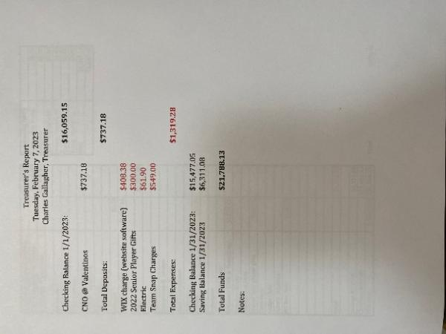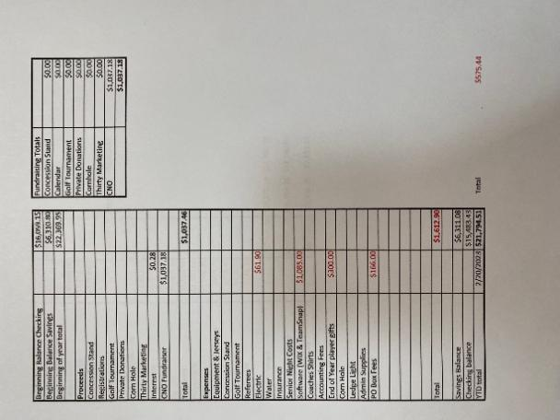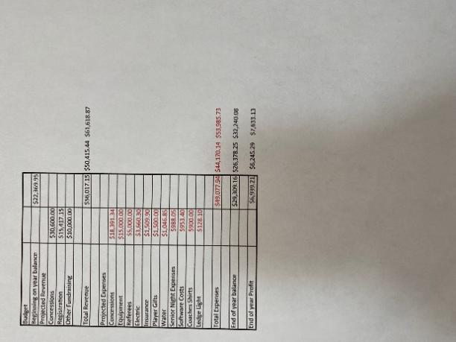

Agenda item: | Ways & Means | Presenter:

Discussion:

Jenn T mentioned that the past 3 fundraisers at Valentinos has brought in $1037. We have one more on on Super Bowl Sunday.

Agenda item: | Old Business | Presenter: | Thomas Staigers

Discussion:

*Equipment manager: Scott reported that he has been cleaning up the top of the fieldhouse while his son is at basketball practice.

Scott mentioned that the equipment has been sent out to Stadium Systems and we should have them back by June as of now.

Matt asked about how many are expired which was 7 and this coming year will be about 23.

*Bylaws: We are suppose to vote in new bylaws however there were some concerns.

Jenn T has some concerns, she started going over other town bylaws and would like to add a separate item. Christine mentioned that would have to be sub committees under Ways and Means.

Tommy mentioned since there are so many concerns we should have more meetings before we vote yes.

Josh mentioned that when we have additional meetings we should have a zoom link so others can join if they want.

Jesse Leckie mentioned that other schools have $100,000 in their accounts and Jenn stated that we should fundraise all year we are missing out on money.

Ashley asked if we can add bylaws as need, Tommy said yes, however it was mentioned that it then would just become more addendums versus bylaw.

Three more meetings need to be set just for bylaws, meetings will be set by Tommy and final bylaws will be approved in May.

It was asked that if we could have additional meetings to add/adjust bylaws in years to come and Tommy said yes.

*Cleaning lady: Josh stated is down for whenever we get hot water. Price would be about $600 for a deep clean.

We need to discuss with baseball and see when they are going to take over so we can get in the day before to get it cleaned.

Chad mentioned that we still need to have the water bill zeroed out before the water can get turned on.

*Fundraising Letter: Tommy is still finalizing the letter and will be giving it back soon.

Jenn mentioned she needs an updated letter to give to Valentinos.

*Golf tournament: It was mentioned that Justin Carter at Lake of Isles is back. Matt said that if he hasn’t heard from River Ridge we would just stick to Lake of Isles.

Matt is going to take point on the golf tournament.

Tommy mentioned possibly starting a golf committee.

*Scoreboard: Tommy asked about the date on when the scoreboard would be done. Josh mentioned that they are still building it, he sent the approval email to the company at the Jan meeting and it would be at least 10 weeks.

Josh stated that the L with the sword didn’t have a vector and on Jan 25th it had gotten a vector and was put into production

*Flag pole: Chad mentioned that United Way doesn’t own the flag pole and he said he would dig into further.

Scott said it will be painted and a flag will be hanging from it next season.

*Amazon smile: As of Feb 22nd Amazon smile will be discontinued and if anything has been purchased an automatically in the account in 45 days. Chad mentioned that nothing has been deposited as of now into the account.

Agenda item: | New Business | Presenter: | Tommy Staigers

Discussion: Representation at League meetings

Scott mentioned that the Southern NE Conference bylaws states that they need a list for who can attend meetings and vote, he mentioned that if should be the board members in order. Tommy will send over the list.

Jesse asked that if football and cheer aren’t combined can she vote for football if no one from the league is there, the answer is no.

The first conference meeting of the season is Feb 20th and its potluck.

Agenda item: | Announcements | Presenter: | Thomas Staigers

Discussion: Deon mentioned that P&R said that if we don’t ask for things than we wont get them. So if there are things we need/want we need to ask.

Tommy is going to schedule the bylaw meeting asap and will send it out and post on the website

Meeting adjourned at 7:36

Motion by Tommy seconded Chad

