Attendees: | Tommy Staigers, Scott Williams, Jessica Smith, Matt Burke, Jessica Gross, Kathy Williams, Jesse Leckie, Jennifer Texiera, Christine Mosley, Ashley Burke, Dan Emery, Tim Weldon, Kristin Deccico, Paul Picken, Sarah Beth Picken, Dawn Taggart
Please read: | This is an open forum please be respectful of everyone in attendance, share the time. To avoid missed information please avoid cross talk and talking over each other.
Minutes
Agenda item: | Secretary | Presenter: | Jessica Smith
Minutes

Tommy presented the minutes from the Feb General meeting as well as the executive board meeting.
While discussing previous Executive board meeting mins it was mentioned that Chad would be taking over registration responsibilities. The league is going to shift from using TeamSnap over to the league website. The website can do the same thing that we pay to have TeamSnap do.
Sarah Beth questioned why Paul is no longer in charge of doing registrations.
Matt and Tommy explained that due to the sensitivity of the information given that an executive board member needs to be in charge of registrations.
Jenn T asked why not utilize other members of the general board.
Paul mentioned that he sent weekly reports to the coaches as well as the treasurer on who had and had not paid.
Jenn T asked if there will there be a spot for volunteering for fundraising which Tommy said yes. She also asked if we will know what fundraising we will have so parents can sign up for the fundraiser they would like to do.
Ashley asked if there would be a spot for opting out of fundraiser and an additional cost which Tommy did mention that it was discussed as a possibility.
A fundraising idea was mentioned about doing a 50/50 raffle during home games and Jesse Leckie mentioned that the cheerleaders have done that as a fundraiser so she was concerned if football does it they wouldn’t be able to. Tommy said that cheer can keep doing it.
Matt said that when Anthony is back we will set up dates for a fundraising meeting and invite whomever would like to be a part of it.
Agenda item: | Vote in and accept New Members | Presenter: | Tommy Staigers
Discussion: Tommy made a motion to vote in new members, Matt Second the motion Jess and Scott agreed.
Dawn Taggart
Christine Mosley
Agenda item: | Treasurers Report | Presenter: | Jessica Smith
Discussion: See below for full details on reports.
Report given by Jessica due to Chad being away for work.
Chad mentioned in his report that Parks and Rec paid the irrigation bill and that he would work with them to have the water turned on if needed.
Chad also mentioned in the report that as of March 5th the last Valentinos fundraiser check had not been deposited.
Jenn T stated that she did give the check to Anthony for the amount of $323.00.
Christine asked if there was a breakdown of how the amount was figured since Jen mentioned last month that Valentinos was just giving us money. Jenn mentioned she did not have a breakdown however Sarah Beth mentioned that essentially, she was giving us the waitresses tips. Jenn mentioned that there was no breakdown and that the owner was just giving us a percentage of what was earned for those four fundraisers.
February monthly report Year to date report 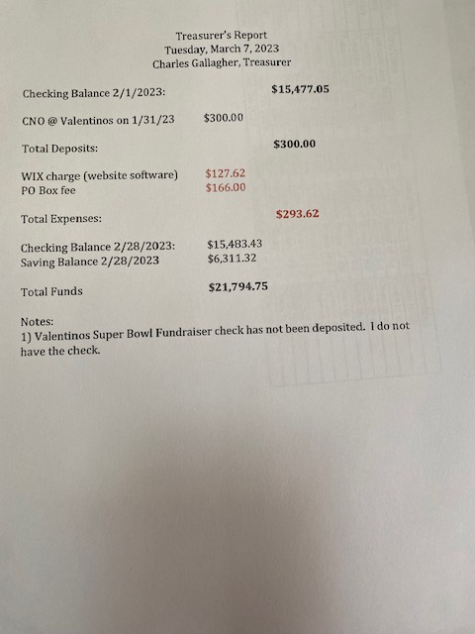 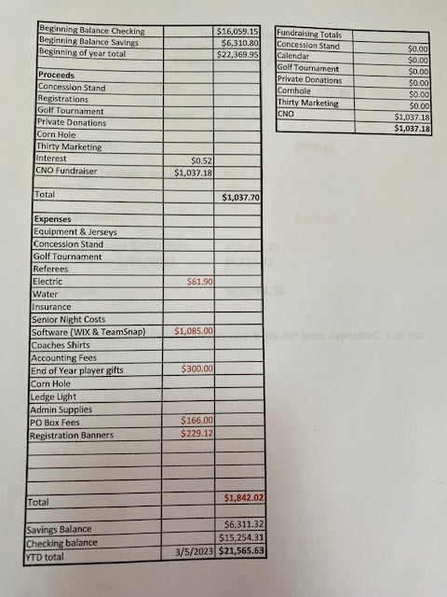
Agenda item: | Ways & Means | Presenter: | Jessica Smith
Discussion: Anthony gave Jessica his report due to being out of town for work.
Anthony mentioned that we still need to get the concession stand cleaned and turned over to Baseball.
Now that the irrigation bill is paid Tommy is going to reach out to Scott at Parks and Rec and try to set up a date to have the water turned on so we can get the cleaning lady in there before April 22nd which is baseballs opening day.
Agenda item: | Old Business | Presenter: | Thomas Staigers
Discussion:
*Bylaws: Tommy mentioned that he will be setting up 2 meeting for the month of March since we didn’t have one for Feb.
Tommy also mentioned that he will make copies of the bylaws to hand out for discussion at the meetings.
Christine asked who had the original 2019 Bylaws since they are not posted on the website anymore. Jessica mentioned the one that she had it unfortunately had updates to it. Matt mentioned he had a copy and he would send it over.
*Golf: Matt mentioned that he talked to Justin at Lake of Isles and we are good to have hole sponsors.
Matt mentioned we need to set a donation amount for hole sponsors. Matt was thinking somewhere around $150 dollars.
Jess mentioned she would talk to Thirty Marketing about doing the signs and getting a price for how much signs would be.
Tommy would like to get a group together to be in charge of fundraising for the tournament.
Jenn T asked if there was a list of sponsors from before which there is not.
We would like to have signs done by May 1s so that way we can make sure they get to Lake of Isles 2 days before the tournament.
Jess and Ashley said they will do registration and drive around the course taking pictures and anything else that needs to be done.
Agenda item: | New Business | Presenter: | Tommy Staigers
Discussion:
Report of the equipment manager: Scott discussed that he would like to make a motion to spend an amount not to exceed $5100 dollars from his budget on things we need for the league.
Scott would like to purchase:
Mouth pieces not to exceed $200.
8 Pylons not to exceed $200.
1 set of down markers not to exceed the amount of $400.
Footballs not to exceed the amount of $500.
Home Depot not to exceed the amount of $300.
- This is for the purchase of sled paint supplies, sand paper, nuts, bolts, epoxy paint, shelving brackets, stencils, picture frame hooks, storage bins etc.
Pants not to exceed the amount of $1500.
- Purchase about 40 pairs
Jerseys not to exceed the amount of $2000.
- 50 of the same jerseys to include fitting the peewees 2-3 life span not to exceed $40
Scott discussed with everyone what he would like to purchase and why.
Scott mentioned that he recommends that we stay with the jerseys we have now and purchase smaller sizes and fill in what we need. He thinks maybe next year move to purchasing newer better quality jerseys and start with seniors.
Jenn T mentioned have we tried getting a grant for the purchase of jerseys? Scott had not looked into one and Jenn said she would look into seeing if there are any grants out there,
Scott made motion to spend the amount of $5100 dollars Tommy and Matt seconded.
Jesse did ask that when we do decide to purchase new jerseys to please let them know ahead of time since their uniforms match ours and will have to change theirs.
Scott made a motion to not to exceed the amount of $2100 for 10 helmets.
Discussion: Scott mentioned that as of December time frame he was told we shouldn’t have any issues with the supply of helmets. He has recently found out that that is now not the case.
Tommy and Matt seconded.
Matt asked if we need to purchase more shoulder pads. Scott said we have 148 and that we may need to order more. We do have the money to order more but there isn’t a manufacturing issues so we should be good to hold off to order them.
Agenda item: | Announcements | Presenter: | Thomas Staigers
Discussion:
The League received a check for the amount of $550 for the cheer competition and instead of splitting with the cheer league we decided to give them the whole check.
Jenn mentioned to Tommy that she still needs the fundraising letter to give to Valentinos for the fundraising. Tommy said he has one that he has been modifying and will get that send to her soon.
Jenn mentioned that her job Charter Oak bank would make a donation once she has the letter.
Jess asked for a league stamp for when we send out letters to companies for donations. She will discuss with the treasurer when he is back in town.
Tommy mentioned that he would like to have picture day this year all on the same day and possibly setting up a kick, punt, pass fundraiser for the same day.
Tommy mentioned that at the Executive board meeting we had this past week that all members signed a code of conduct report. He said that anyone that wants to be a part of the general board will have to sign one as well and will have that form at the next meeting.
Jess mentioned she is still waiting on the Junior head coach Paul and his coaches signed code of conduct form to file away.

Tommy made a motion to adjourn the meeting.
Scott second
Meeting adjourned at 7:01

