Ledyard Youth League | 10/13/2022  7:16 PM  Judge Crandall Field
Attendees: | Tommy Staigers, Chad Gallagher, Jessica Smith, Scott Williams, Dan Grimm, Paul Picken, Stacy Bernier, Sara Beth Picken, Jesse Leckie, Jennie Thomas, Jennifer Texeria
Please read: | This is an open forum please be respectful of everyone in attendance, share the time. To avoid missed information please avoid cross talk and talking over each other.

Minutes
Agenda item: | Treasurers Report | Presenter: | Chad Gallagher

Discussion:

Chad discussed the treasurer’s report see copy below.

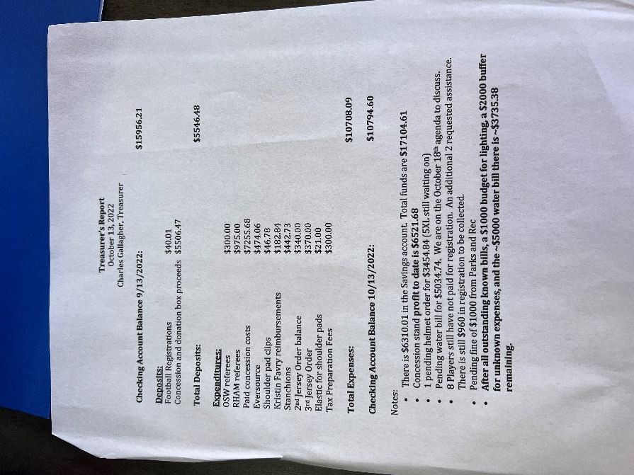
New water bill of $332.26 to be paid by Chad. The fine that we received for using the field has been removed from us. Chad will be building the next year’s budget based on this year’s finances.
Agenda item: | Parks and Rec meeting | Presenter: | Tommy Staigers

Discussion:

Tommy met with Scott from Parks and Rec on 10/12/2022 to discuss our fine for the use of the when they said it was closed. They stated they were going to fine us for $1800 for damaging the field since it was recently reseeded. Tommy mentioned that we are not going to be fined but they discussed we need to have a contingency plan when the fields closed. Parks and Rec stated that M-S they have control over the field on Sunday we have control.

Discussed that the next monthly Parks and Rec meeting is Tuesday Oct 18th at 7pm where we are on the agenda to discuss the water and light bills.
Agenda item: | Fundraising/ Donations | Presenter: | Tommy Staigers

Discussion:
Tommy mentioned that the Rotary Club has a $2000.00 donation that they give out all they need is an essay stating what it would be used for. United Way has a donation that they will give out if we submit at the beginning of the year.
Tommy mentioned that maybe adding in the option of having families do a fundraiser for part of the registration cost i.e. selling candy bars.
Paul mentioned that Smile.Amazon.com is an option to gain donations as people just
have to shop with that link as normal and we gain proceeds
Chad asked if there were any leads on the calendar fundraiser and will reach out to Anthony and
Ashley to see where we were at.
Agenda item: | Senior Night | Presenter: | Jessica Smith

Discussion:

Need $120 to pay for items needed for senior night. This was for purchasing of flowers, balloons and flyers.

Motion to approve Chad, Seconded by Tommy. Motioned carried 4 approved

Jessica asked if $500 of profits from thirty marketing fundraiser could be used for cost of banners and then have parents pay the difference. Dan mentioned having the league pay the remaining balance after the fundraising on Saturday and the $500 from thirty marketing. Cost for banners will not be known until after Saturday’s game.
Agenda item: | Bylaw Rewrite | Presenter: | Tommy Staigers

Discussion:

Date of meeting to start rewrite needs to be set so that we can have it done by the end of the year.
Agenda item: | Cheer | Presenter: | Jesse Leckie

Discussion:

Jesse would like to have a reconsideration to cheer and football merging again. Tommy said that we can discuss and see what agreement can be reached.

Meeting adjourned at 8:11

Motion by Chad seconded by everyone

